**Project Specification Document**

1. **Project and Developer details:**
   1. **Project details:**

* Code to display the welcome screen. It should display:
* Option for Admin Login.
* Option for search available flights.
* Option 1: Admin Login,
* If Admin try to login with invalid Username and password it shows massage on screen invalid credentials.
* If Admin login with correct credentials it displays list of available operation for admin.
* Admin home page shows below list operations:
* All available places.
* All available Airlines.
* All available Flights.
* Option for admin change password.
* Option 2: Search available flights:
* After clicked on search available flights it is show all available flights with source destination and price.
* In the page it is allow user to enter of travel details, like the date of travel, source, destination, and the number of persons.
* Based on the travel details entered, it will show the available flights with their ticket prices.
* It’s also show option for user registration before book your flight, so registration is compulsory for booking.
* For registration page it’s ask for username, password, first name, last name, address and phone no.
* After successfully registration its redirect to customer details page.
* In customer details page, it asks your no of person for travel.
* Based on no of person, we need to enter passenger details.
* Passenger details included: passenger name, UID number, phone no and age
* After entering all passengers details it will be redirected to payment page.
* In the payment page, it will ask you debit card no, expiry date and CVV.
* This page once again asks your number of persons for travel.
* Based on no of person it will debit the amount for your selected flight from your account and show you payment successful massage on screen
* After complementation all process for booking in last it will show one massage on the screen your flight ticket booking successful.
  1. **Developer Details:**

Application is developed Chhaya Askar and As a Full Stack Developer, I have designed and developed an airline booking portal named as “**Flyaway”.** The goal of the company is to deliver a high-end quality product as early as possible.

**2. Sprint Planning:**

**Task 1**: Develop code to display welcome page including two option admin login and search available

flights.

**Task 2**: Admin login page.

1. wrong username and password it’s don’t allow to login show invalided credential
2. Correct credential it all admin login and shows all 4 available options:
3. All available flights.
4. All available airlines.
5. All available places.
6. Admin Change password.

**Task 3:** Search available flight for user

Its show all available flights with source and destination. the page it is allow user to enter of travel details, like the date of travel, source, destination, and the number of persons. Based on the travel details entered, it will show the available flights with their ticket prices.

**Task 4:** Registration details

Once your flight available next step is Registration, in registration form must enter username, password, first name, last name, address and phone no. After successful registration it will ask your number of persons for travel and details like name, UID, phone and age.

**Task 5:** Payment details

Once user enter all passengers’ details it will ask for payment details like debit card number, expiry date and CVV. once payment successfully portal shows message your flight ticket booking successful.

**3. Algorithms and flowcharts of the application**

**3.1 Algorithms:**

1. In this application I used HTML to take input from user.

2. User JSP and servlet concept for business related logic

3.User Tomcat server to connect my application to Database.

4. User MySQL Database to store application data.

**3.2Flowchart**.

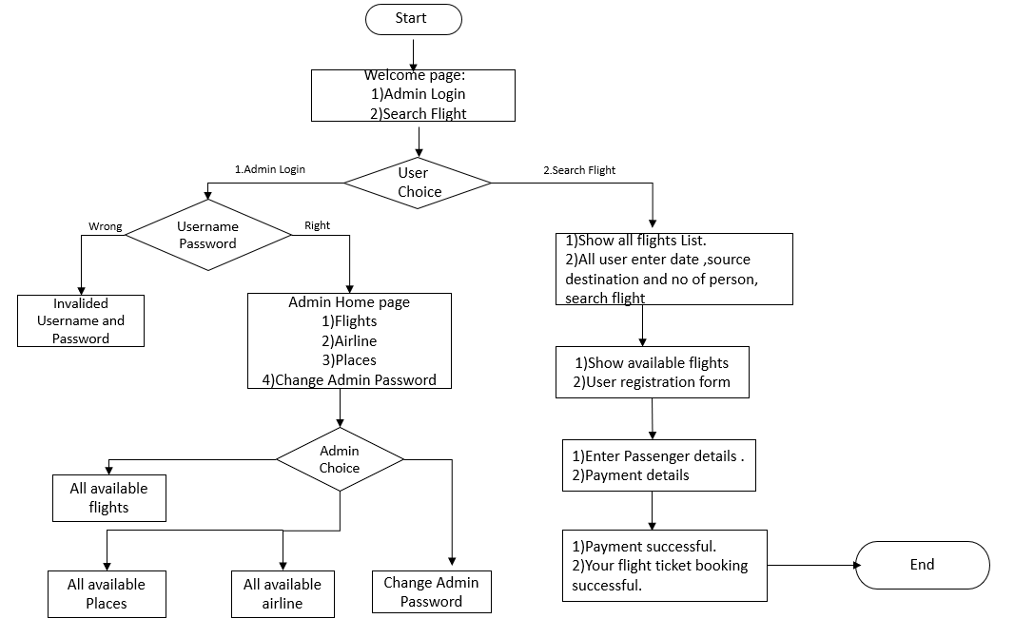

**4. Core concepts used in the project Concepts used in developing the application are**

1. Eclipse IDE
2. MySQL Relation Database Management System
3. Apache Tomcat server
4. Java Servlets
5. Java Server Pages (JSP)
6. HTML
7. JDBC Java Database Connectivity
8. SQL

**5. Links to the GitHub repository to verify the project completion**